Module 5 – Making it Happen. Being Accountable.

Mentor Guide
The focus of this session is on ‘Being accountable’ and making things happen.
Overview of Mentoring Circle session – 60 minutes (immediately following 60-minute Our Watch session on ‘Making it Happen’)
- Reflecting on the 4 principles (10 mins)
- Accountability “panel” - Sharing Gender Equity Commitment and Action Plans (40 mins, approx. 10 mins per participant)
- Wrap Up (10 mins)
Reflecting on 4 principles
This item: 10 mins
Cumulative: 10 mins
- To say:
At the Our Watch Session, we were shown 4 principles for allyship from the ‘Working Together with Men’ resource. Let’s take 10 minutes to look more closely at these principles and discuss how you’re thinking about putting them into action.
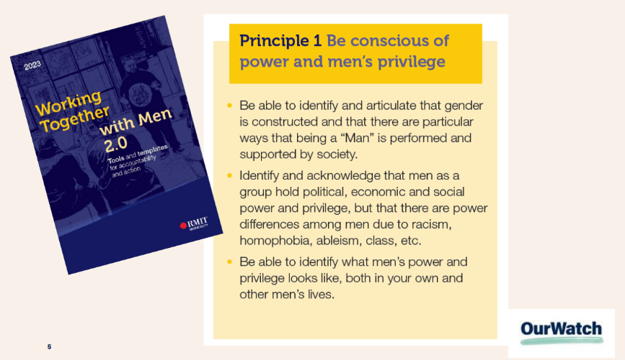 | 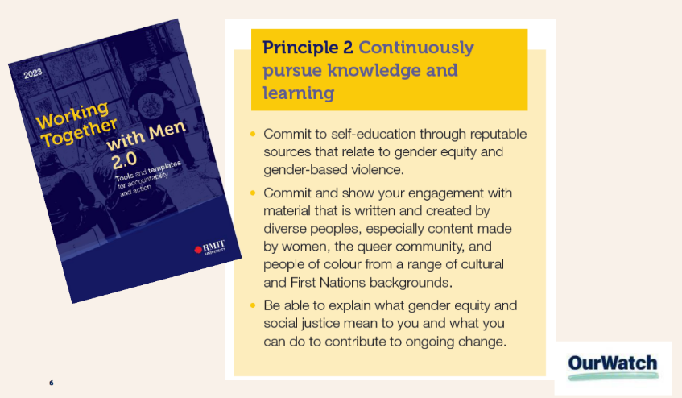
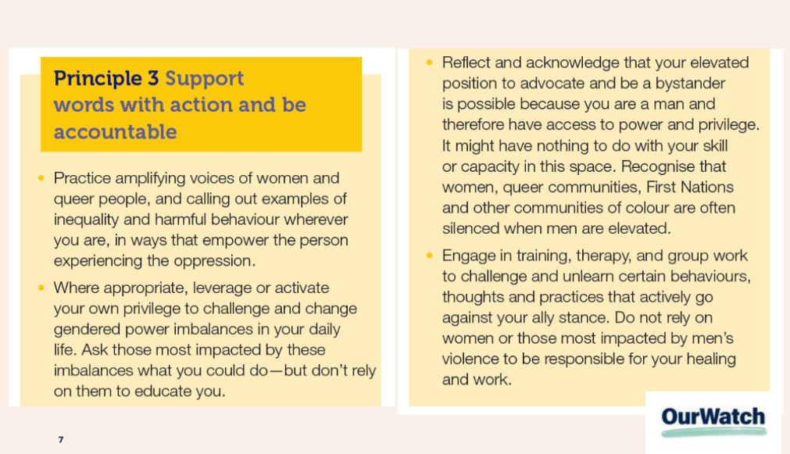 | 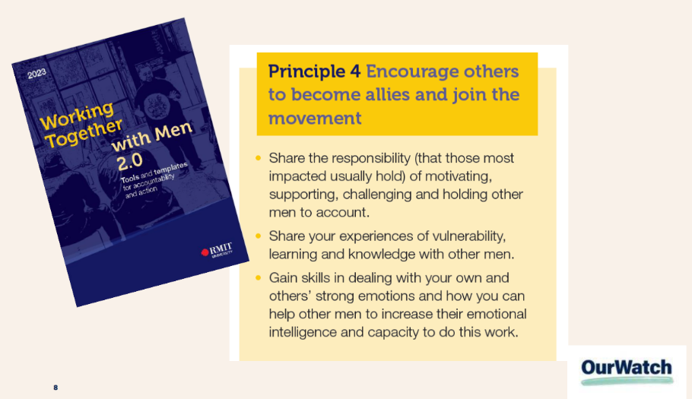
Potential questions re 4 Principles:
- What practical actions can you take to embed these principles into your practice? Add these to your Gender Equity Commitment and Action Plan.
- How well do you think you’re going with each of these principles?
- What else might you need to do or learn?
Accountability “panel” - Sharing Gender Equity Commitment and Action Plans
This item: 40 mins
(Approx 10 minutes per GEM Mentee)
Invite your circle to act as an ‘Accountability panel’ and ask each mentee to share the actions they have captured in their Gender Equity Commitment and Action Plan.

Invite mentees to give each other feedback. As a mentor, share your workplace learnings from when you have seen such actions brought to life well and not so well!

You can also use the GROW coaching model to prompt and support each participant to;

G – set clear goals
R – reflect on the reality, challenges, resources and limitations they’re facing
O – explore opportunities and ideas
W – agree on “will-do" next steps

Workshop any of their action ideas that they would like more advice on.
Wrap-up – 10 mins
To say:
Group check-out – invite your mentees to reflect on the very next step which they will take to bring their actions to life at work or home.

Self-care and support – invite mentees to seek support if they need it.
Final session – on June 17 we will come back together to close the 2026 GEM program and reconnect for one final mentoring circle breakout session. In the meantime, ask mentees to please start delivering on their Action Plan.

